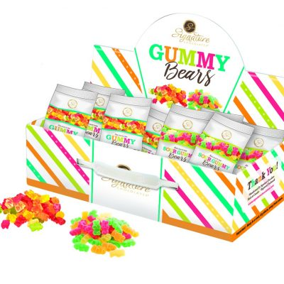
Calling all band class, marching band and color guard members!
Sell sour and sweet gummies and earn $30 for your band account for every box sold.
Each box contains 60 delicious items in two varieties –Gummies and Sour Gummies.

How the sale will be run:
- Have this permission slip signed by your parent ASAP.
- Gummy boxes will be available for pick-up on Thursday, October 10th, after rehearsal (assuming no delay in delivery). You must return your signed permission slip to receive your first box of candy.
- Sell your box as quickly as possible! Be smart – NEVER leave your candy or money unattended, even in the classroom. Protect your box from heat, direct sun or refrigeration.
- Return $60 for your box BEFORE SCHOOL from 8am-8:15am ON MONDAYS, Wednesdays and Fridays (starting Wednesday 10/16) at the band candy closet and sign out another box to sell if you wish! Payment may be made in cash (bills only – no change!) or checks (from parents only) payable to CHS Band Boosters, with “Gummies” in the memo line.
- Repeat steps 3 and 4 as often as you want before November 15, 2019!
Questions: Contact Sarah Cavanaugh at sarahc51977@yahoo.com
-----------------------------Return the signed permission slip below in exchange for your first box of gummies ---------------------------------
Centennial Band Gummies Fundraiser
Name of Student: __________________________________ Name of Parent:_________________________________________
We will participate in the Centennial Band Gummies Fundraiser. Please give the student named above one initial box of 60 items, in exchange for this permission slip. We will be responsible for payment for all candy that we check out, including the initial box and any subsequent boxes, whether sold, unsold, missing, or damaged. We will return all money owed by Monday, November 17, 2019. We also understand that candy is a perishable item, and it must be kept from extreme heat or refrigeration.

Parent Signature:___________________________________ Parent’s Phone:__________________________________________

